**Software use to develop the application**

Node JS

React JS

Express and Mongoose modules

Mongo DB

First start the mongo db database : using mongod

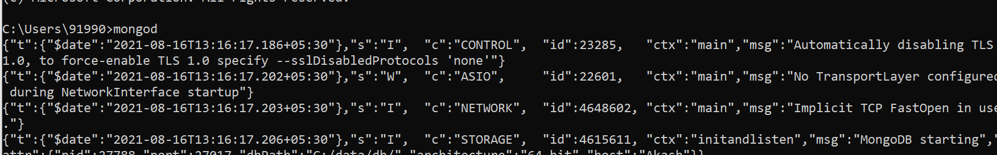

Then run the mongo command in another terminal to run the mongo db terminal

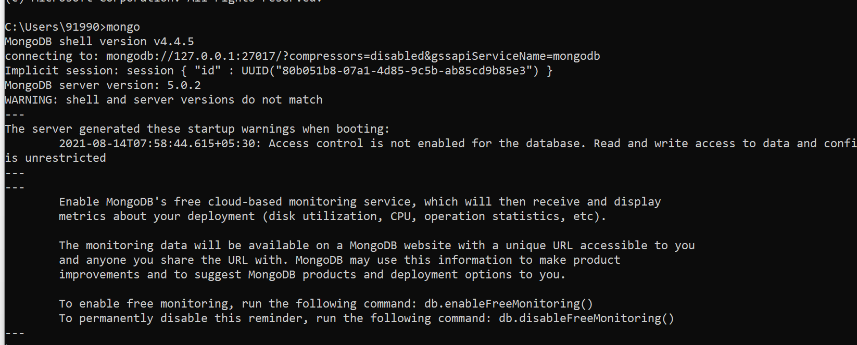

All collection details in grocers database.

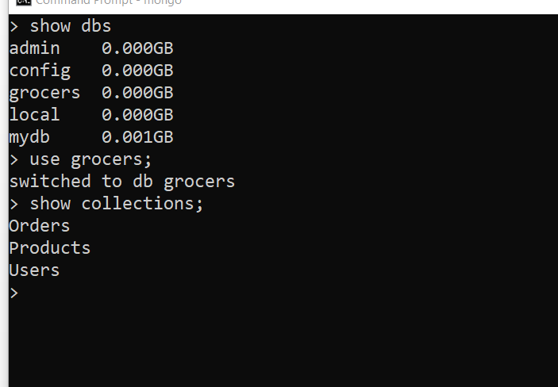

Document from Orders collection

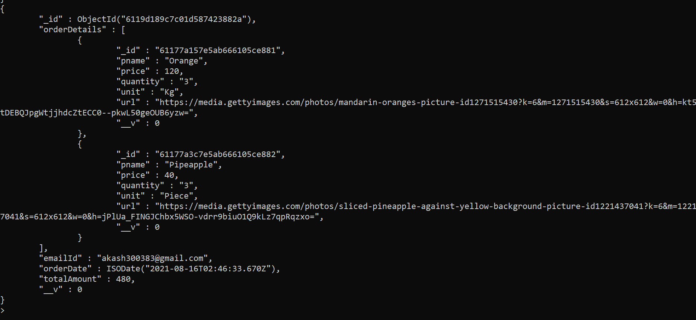

Document from Product collection

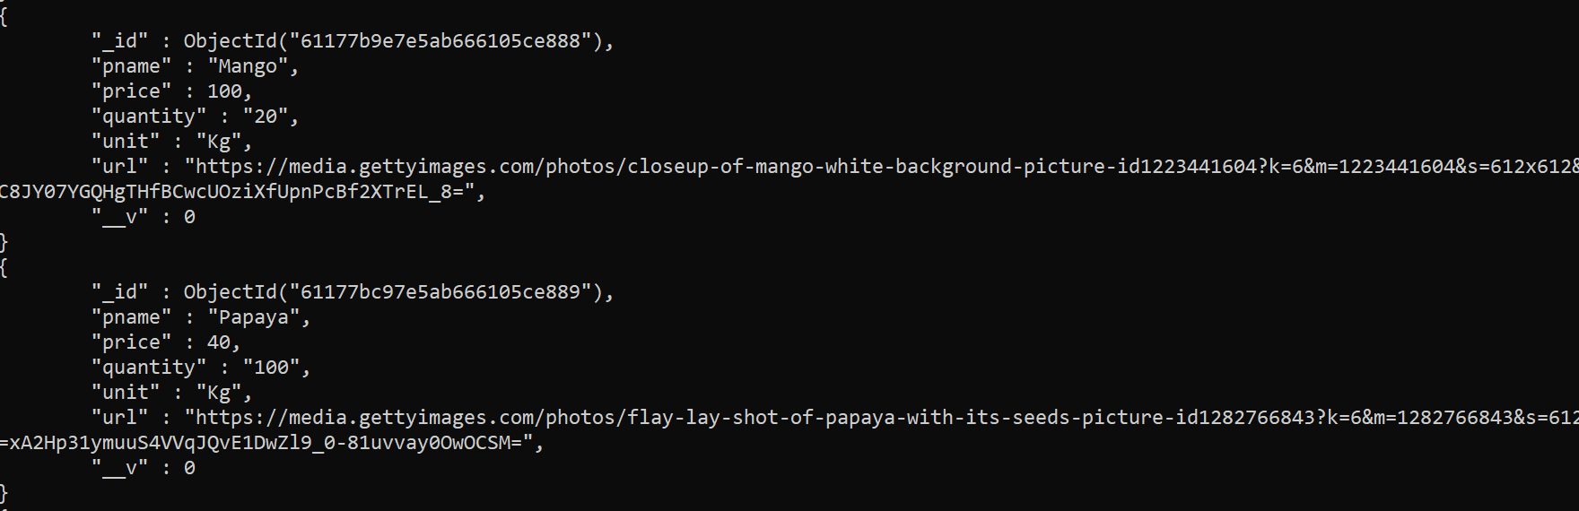

Document from users collection

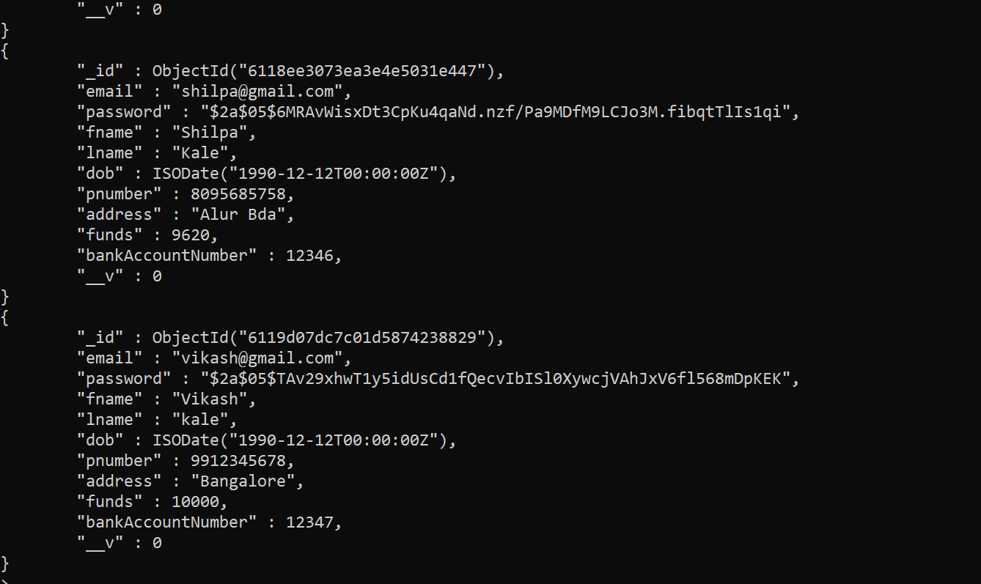

First run the command as npm install inside express js project

Then run the express js application using the command as

From backend folder

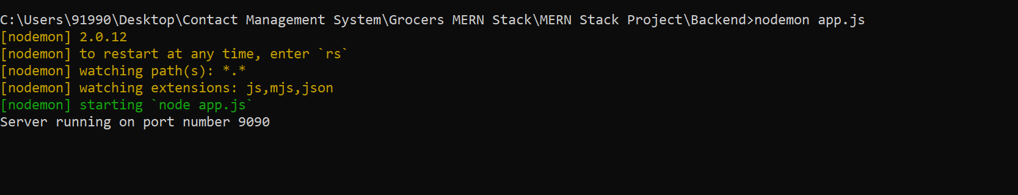

First run the command as npm install inside react js project

Then run the react js application using the command npm start from grocers-ui

